Connectix QuickCam for Macintosh Webcam: How a New Era on Your Desktop Begins and How Big Brother Appreciates It

Abstract
As the first consumer-grade webcam in the world, Connectix QuickCam led the revolution of peripheral devices as soon as it was born. Furthermore, such a product, together with its successors, became the foundation of web video communications, the prosperity of social media and many other uses as time went by. Though a great many alternative solutions, which are quite cost-efficient, have replaced them in most use cases nowadays, products like this still serve a niche market for professionals. In this paper, starting with Connectix QuickCam, we’ll talk about the emergence and development of such a sort of product, how it changes the social life people are enjoying, and its mutual relationship with the technologies before and after its appearance. And as is shown in the title, we’ll also discuss the various concerns such as privacy it has brought about.
Keywords: Connectix QuickCam, Webcam, Video, Social Media, Privacy

Introduction to Connectix QuickCam, the first consumer-grade webcam in the world
QuickCam is a line of webcam video camera products originally produced by Connectix in 1994, which was acquired by Logitech in 1998.^{[1]} Connectix Corporation was a software and hardware company that released innovative products, most of which were sold to other companies once they became popular. Its another famous product is Virtual PC, which was finally acquired by Microsoft.^{[2]}

The original QuickCam was developed for US-wide commercial sales and was the first widely marketed webcam-like device, though its original advertising did not use the term “webcam” or refer to the World Wide Web. It evolved from an RS-422 connector to a parallel connector then eventually to a USB connection. The initial model was available only for the Apple Macintosh, connecting to it via the serial port. It produced 16 shades of gray at a resolution of 320×240 pixels, and could record video at about 15 frames per second. The software that originally shipped with the camera included QuickMovie for recording motion pictures and QuickPICT for capturing still images. The price of QuickCam is rather moderate, 100 dollars.^{[1]}

QuickCam is originally the sole design of Jon Garber, one of the creators of Connectix Corporation, who wanted to call it the “Mac-camera”, but the idea was vetoed by marketing, who saw the possibility of it one day becoming a cross-platform product. It became the first Connectix Windows product 14 months later. The Mac QuickCam shipped in August 1994, and QuickCam for Windows in October 1995.^{[2]} In October 2010, QuickCam was elected to Time Magazine’s Top 100 Gadgets of all Time.^{[3]}

After being acquired by Logitech in 1998 at a price of 25 million dollars, QuickCam product line underwent several iterations over the years. Though the brand has been deprecated in 2000s, it has been synonymous with “webcam”.

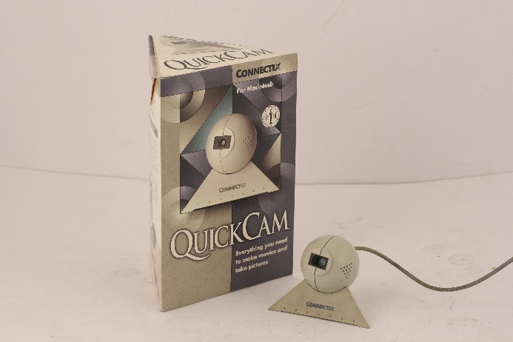
Figure 1 QuickCam ©Museo Nazionale Scienza e Tecnologia Leonardo da Vinci

More than just a peripheral, Connectix QuickCam is also an icon of its era. It marked a critical transition for personal computers, shifting them from simple computing machines to multimedia and communication platforms. By providing users with a completely new way to observe, record, and share the world, it brought life into a static digital landscape. Although its capabilities may appear primitive now, the desktop video revolution it led to continues to deeply influence our digital existence today.

An historical overview of QuickCam
The original target customers of QuickCam are common computer users, especially those who own Apple Macintosh, which is implied by its first name mentioned above. Its affordable price strongly implies that it’s aimed at consumer-grade market. The fact that QuickCam was shown in public for the first time at the Bayside Expo Center during Macworld in Boston in 1994^{[4]} is also persuasive evidence to prove that it was designed for Macintosh in the very beginning. However, thanks to marketing of Connectix, QuickCam for Windows was released a little more than 1 year after the sale of Macintosh ones.^{[2]} Besides, QuickCam connects via the serial port of computer, getting rid of complicated and expensive video capture cards that used to be mandatory for digital videos.

QuickCam was invented to make digital videos an everyday application for most computer users, which was unimaginable before. To be more detailed, it democratized digital videos and enabled typical applications such as video conferencing. It also facilitated content creation, as is shown by the software shipped together. These uses greatly matched the expectations of Connectix.

Nowadays, the successors of QuickCam play an important role in our social life. Without them, we have no way to chat with our friends or relatives face to face when we are apart. We wouldn’t be able to improve efficiency of commercial activities when the corporation is large or even worldwide. Moreover, livestreaming of the man in the street, which we take for granted today, is empowered by these webcams as well. We’ll talk about such a popular social phenomenon later.
The technical revolution of webcam products like QuickCam and its subsequent models is aligned with that of cameras and video recorders. This is because they shifted from CCD to CMOS almost simultaneously. QuickCam Pro 4000, a symbolic model of QuickCam product line released by Logitech in 2002, still adopted a CCD solution. However, QuickCam Fusion and QuickCam Orbit released in 2005 swiftly turned into CMOS solutions, just like most digital cameras and video recorders welcomed by customers in the same era.^{[1]} Such a decisive shift is the revolution for the whole digital image industry, since CMOS technology dominates CCD in many aspects. First, it can greatly reduce the cost of production, since they can be mass-produced on the same assembly lines with other computer components such as memory and processors. Second, the power consumption of CMOS is much lower than that of CCD, therefore it can be adopted in wider circumstances. Besides, the integration of CMOS is higher, which means products like webcams can be designed into tiny sizes. Last but not least, the readout speed of CMOS outperforms that of CCD a lot, and the pixel information in it can be read individually or by row. This is the basis of high frame rate video recording.^{[5]}

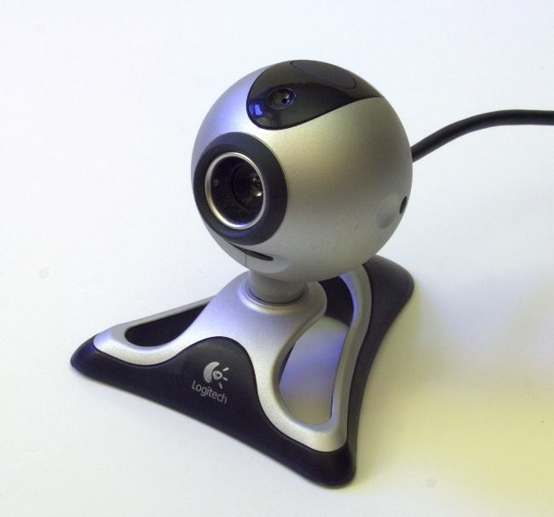
Figure 2 QuickCam Pro 4000, Originally Released in 2002

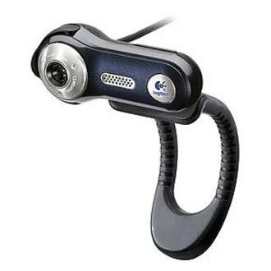
Figure 3 QuickCam Fusion, Originally Released in 2005

The mainstream webcam market is highly mature nowadays. Many of the features anticipated in the past have been the current market standard. For the resolution, Full HD 1080p has become a baseline. And professional high-end webcam products usually provide 2K (1440p) or even 4K (2160p) Ultra HD resolutions. Current products designed for game streaming and content creation often offer 60fps video recording, while entry-level models offer 30fps to meet the basic user experience. Like cameras, sensor size of webcams matters a lot. High-end ones usually utilize sensors of 1/2 inch or even larger to achieve better performance in low-light environment and improve overall image quality. Field of view (FOV) also counts. Most mainstream products offer FOVs ranging from 78 to 90 degrees, while some wide-angle models can exceed 110 degrees to satisfy the need of some special situations, like video conferencing. To make it convenient for customers, built-in microphones are considered a must, some of which even support noise cancellation. At present, AI-powered functions, such as subject centering, background blur/replacement and so on, can be a key differentiator among competing webcam models in the market.

Webcam products like QuickCam are standalone webcams. Such products owned a large market from early 2000s to around 2010. However, the market has undergone up till now. The reason is that the whole market has completed a crucial shift: from a necessary accessory to a tool that meets professional needs. At the very beginning, personal devices like laptops and mobile phones with integrated cameras were not so popular, and for those personal computers it’s necessary to buy a QuickCam to enable functions like video chat. In other words, customers needed to go from zero to one. But as time goes by, devices with moderate built-in cameras become widespread. As a matter of fact, these integrated cameras are just good enough for most customers, managing to satisfy their common needs like video chat and web conferencing. Therefore, they lead to a significant decrease in the standalone webcam market.


Figure 4 Integrated Cameras on iPhone

Though, built-in cameras cannot dominate the whole related market. Restricted to the physical space left for them in the body of these mobile devices as well as the manufacturing price, it’s nearly impossible to integrate high-quality cameras into them. That’s why these cameras usually stop at a point where only basic needs are met. Besides, we can regard these built-in cameras as a special type of webcam in some sense. As a result, room for standalone webcams in the market remains, but the target customers shift from common ones to those who require professional-level models. And those entry-level or low-quality webcams may be considered only by custom PC owners, the number of which has declined over years.


Figure 5 Integrated Camera on Mac

Moreover, companies like Apple are trying their best to discourage their customers from getting a standalone webcam. In the past, some Mac users may not be satisfied with its integrated camera and can’t help acquiring a high-quality one. However, with the development of wired and wireless connection, many interesting ideas are realized. After macOS Ventura was released, they can use a newly introduced function called Continuity Camera, which can turn the integrated camera on their iPhone, if they have one and it’s iPhone XR or later, into a webcam for their Mac.^{[6]} Since integrated camera on iPhone is much better than that on Mac, there is no doubt that it will improve user’s video experience. Needless to say, most of these users won’t hope to get an extra standalone webcam again!

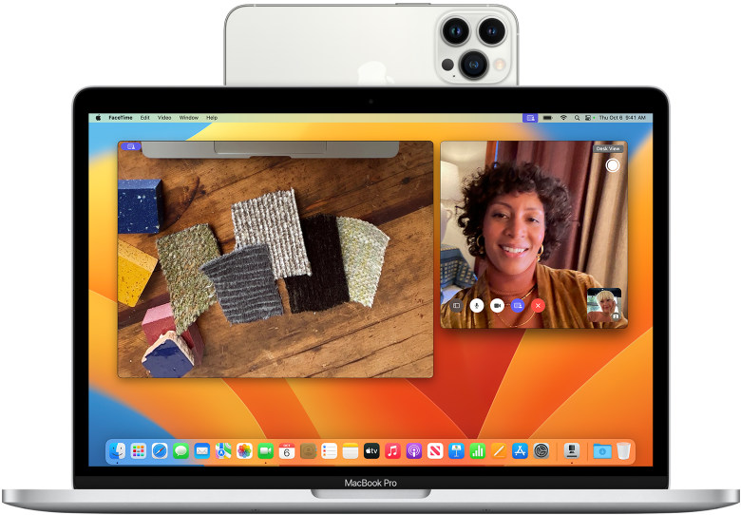
Figure 6 Continuity Camera on macOS Ventura
Built-in cameras on laptops and mobile phones are powerful tools for users under some circumstances. For laptops, video chat and web conferencing are almost the only scenarios to use their cameras. New laptop models may also take them as the hardware to implement face unlock. For mobile phones, besides face recognition, built-in cameras serve as content creation tools nowadays. More and more content creators utilize their mobile phones, especially iPhones, rather than extra video recorders to record or film. Instead of traditional devices, some famous directors have even tried to film with mobile phones. It’s already more than common for streamers to use their mobile phones to stream outdoors conveniently.


Figure 7 Lady Gaga’s Stupid Love, Shot on iPhone 11 Pro

Standalone webcams are still irreplaceable in certain circumstances. When it comes to critical video conferences, built-in cameras often fail to offer video qualities that are high enough. There are still a great many users who have to purchase high-quality standalone webcams to make their images as professional as they can. When streaming in front of the computer, such a webcam can be a better choice even than a video recorder. It’s much easier for users to just point it at the documents on the desk to project them onto the screen than to adjust the position of video recorder. For some special live stream on computers in front of the desk, the view of standalone webcams is regarded much more natural than any other device. Streamers spare no effort to get the scene well-organized, ensuring everything is suitable for their audiences to watch. But such live streams have given rise to another social problem, which we’ll discuss later in the next part.


Figure 8 A Chinese Teacher Using a Standalone Webcam to Project the Document onto the Screen

Figure 9 A Live Stream by a Chinese Girl in Front of a Standalone Webcam

Problems Webcams Caused and Conclusions We Can Draw
While customers like us are enjoying the advantages and convenience webcams bring to us, many related issues also emerge. Just as is implied in the title of this paper, privacy of users has been a great deal.

From early 2000s up to now, as the World Wide Web became widespread, viruses and Trojans that can hack and take control of webcams through Internet came to the forefront and have never disappeared. There are some viruses that can prevent users from accessing their webcams maliciously. For example, a kind of virus can stop your webcam and show a message on your desktop to ask you pay for their “webcam services”, which is quite immoral and can arguably be defined as fraud.

While it’s unlikely that those actions by viruses and Trojans above will cause users excessive damage, some others are vicious. That is, stealthily turning on the webcams to collect users’ personal data and violate their privacy. Such viruses and Trojans access the webcam without any permission from users, record some private video clips, which are then used to extort them. A well-known British anthology science fiction television series, Black Mirror, told a story based on this kind of violation in Series 3, Episode 3, Shut Up and Dance.^{[7]} The problem was so prevalent that a new type of fraudulent email emerged later, blackmailing users by pretending to have hacked their webcam and recorded them. I received such an email once upon a time, feeling nothing but humorous since my personal computer didn’t connect to any webcam then. Some of such viruses can even disable the LED indicator beside the webcam, allowing them to spy on the victim without being suspected. After programs like PRISM were revealed^{[8]}, people have become more worried about their privacy being compromised, thus the anxiety that their webcams are hacked becomes even worse.

To guard against webcam privacy disclosure, several strategies have been proposed. For hardware, it’s recommended to close your laptop or unplug external webcams when not using them. It’s even better to pay attention to webcam placement and keep them away from highly private areas such as bedrooms and bathrooms. Many new laptop models are equipped with webcam covers for their integrated cameras. They also enhance their LED indicators, and now it’s much more difficult to access the cameras without triggering them. Some celebrities such as Mark Zuckerberg use tapes to cover the cameras on their laptops, raising public awareness of privacy protection considerably. As for software, most operating systems have adopted various strict strategies to restrict applications’ access to the cameras when not permitted by users and try their best to notify users when the cameras are turned on.


Figure 10 A Screenshot from Shut Up and Dance, a Black Mirror Episode, Showing Blackmail from a Hacker


Figure 11 The Logo of PRISM

If you think that nothing can be worse than viruses and Trojans discussed above, remember that reality is often harsher than you imagine. This is the case happened in Chinese market, which you will feel absurd even if you are a Chinese citizen. In around 2018, a novel design of integrated webcams on mobile phones was proposed by Chinese smartphone manufacturers. This sort of design utilizes a mechanical pop-up or motorized lifting structure to hide front cameras inside the body of mobile phones so that all-screen displays can be implemented. When front cameras are called, they will eject from the top of phones and retract when finishing accessing. However, it was such design that exposed the widespread issue of applications accessing webcams on mobile phones without users’ awareness or consent. Many users found that the front camera of their mobile phone would eject unexpectedly and then retract when they ran certain apps, like Tencent’s QQ Browser, which should never require access to cameras to provide their main service.^{[9]} Even the third-party keyboard released by another famous Chinese Internet giant, Baidu, was observed to exhibit the same behavior. Why does a keyboard need to access cameras on mobile phones? Though all the giants involved made their own accounts as soon as possible, their reasons were completely unconvincing. The significant public response to this affair garnered the high-level attention of state regulatory agencies. In the following years, China’s Ministry of Industry and Information Technology (MIIT) launched numerous campaigns all over the country, targeting apps that excessively requested permissions and illegally collected user data. This event is now widely seen as a watershed that dramatically raised public privacy awareness and forced an urgent reflection within China’s mobile app ecosystem. At present, such mechanical structures for cameras, which in my view are a design that flies in the face of progress, have become totally obsolete, but it happened to witness the symbolic event of privacy protection of customers in China. All the world’s a stage.


Figure 12 The Front Camera of Vivo NEX, One of the Mobile Phones That Adopted a Pop-up Structure

Privacy concerns are just one of social phenomena related to webcams. Another one stems from live streaming. That is, some live streamers and social media influencers try to cultivate intense, one-sided emotional bonds with their audience for financial gain. They achieve this goal through the power of so-called parasocial relationships, which mean the psychological illusion of intimacy that a viewer feels for a media figure, and finally transform pure human connection into a monetized commodity. In fact, it’s a subtle form of emotional manipulation. These influencers create a persona that seems authentic, vulnerable and accessible. They interact with high-paying fans directly to make them feel seen and special. Fans, often driven by loneliness or a desire for recognition, begin to see the influencers as friends, confidants or even lovers.

Nevertheless, once such an emotional foundation is built, those fans will be financially exploited. They won’t treat requests for money from the influencers as transactions, but as support for friends who need help. To acquire more money, these influencers will even encourage lavish spending during competitive online activities. Such interactions blur the boundary between fan appreciation and a transactional relationship.

The consequences for victims are severe, including, but not limited to financial ruin. They will experience serious emotional distress, betrayal, and shame once they realize the connection they have cherished is no more than an illusion. In our view, it’s clear to see that the whole affair is a scam. Yet it’s complicated to address such affairs, since they often occupy a legal and ethical gray area, making it hard to distinguish between real community-building and deliberate fraud. Finally, we can seldom do anything more than ensuring ourselves away from fraud like this.

As a conclusion, webcams from early QuickCam to current high-quality ones have influenced and reshaped our social lives deeply, though something unpleasant but unavoidable emerged with them. They do make our lives much more wonderful and convenient by enabling video chats, content creation and live streaming. All in all, in my opinion, the peripheral itself isn’t guilty, thus it’s too ridiculous to have it take responsibility for all the related negative effects. As the saying goes, guns don’t kill people; people kill people. We can definitely choose to make use of webcams to make our social lives more wonderful, rather than to do anything evil.

References
- Wikipedia contributors. (2025, August 11). QuickCam. In Wikipedia, The Free Encyclopedia. Retrieved 17:09, August 30, 2025, from https://en.wikipedia.org/w/index.php?title=QuickCam&oldid=1305273918
- Wikipedia contributors. (2024, May 17). Connectix. In Wikipedia, The Free Encyclopedia. Retrieved 17:11, August 30, 2025, from https://en.wikipedia.org/w/index.php?title=Connectix&oldid=1224256043
- Peter Ha (25 October 2010). "Connectix QuickCam — All-TIME 100 Gadgets". TIME. ISSN 0040-781X. Archived from the original on 26 January 2011. Retrieved 2024-10-28.
- Anbinder, M. H. (1994, July 18). Connectix is watching. TidBITS. https://tidbits.com/1994/07/18/connectix-is-watching/
- Basler. (n.d.). CCD vs. CMOS. Basler AG. Retrieved September 1, 2025, from https://www.baslerweb.com/en-us/learning/ccd-cmos/
- Apple Inc. (n.d.). Continuity Camera: Use iPhone as a webcam for Mac. Apple Support. https://support.apple.com/en-us/102546
- Wikipedia contributors. (2025, August 26). Shut Up and Dance (Black Mirror). In Wikipedia, The Free Encyclopedia. Retrieved 04:14, September 2, 2025, from https://en.wikipedia.org/w/index.php?title=Shut_Up_and_Dance_(Black_Mirror)&oldid=1307975044
- Wikipedia contributors. (2025, August 17). PRISM. In Wikipedia, The Free Encyclopedia. Retrieved 03:56, September 2, 2025, from https://en.wikipedia.org/w/index.php?title=PRISM&oldid=1306368563
- Lam, O. (2018, July 9). Chinese mobile phone cameras are not-so-secretly recording users’ activities. Global Voices. Retrieved from https://globalvoices.org/2018/07/09/chinese-mobile-phone-cameras-are-not-so-secretly-recording-users-activities/

